That-Clause as a Verb Complement

✅ What Is a That-Clause as a Verb Complement?
# Source: AI Source: Provided by: [Data Path: Persons Table -> ID Column: 1, Name_En Column: Motasem Essam] -> From: [ChatGPT] on [8/4/2025]
A that-clause is a dependent clause beginning with “that”, functioning as a noun to complete the meaning of the main verb. It often expresses beliefs, thoughts, perceptions, or statements.

🔸 Structure:
# Source: AI Source: Provided by: [Data Path: Persons Table -> ID Column: 1, Name_En Column: Motasem Essam] -> From: [ChatGPT] on [8/4/2025]
- Verb + that + clause
- Common after verbs like: believe, think, say, know, hope, realize, admit, etc.

🔸 Examples:
# Source: AI Source: Provided by: [Data Path: Persons Table -> ID Column: 1, Name_En Column: Motasem Essam] -> From: [ChatGPT] on [8/4/2025]
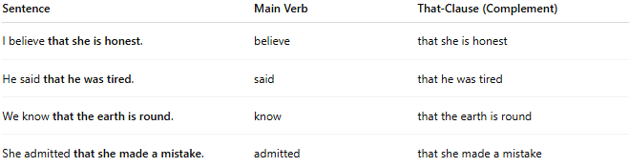
Sentence | Main Verb | That-Clause (Complement)
I believe that she is honest. | believe | that she is honest
He said that he was tired. | said | that he was tired
We know that the earth is round. | know | that the earth is round
She admitted that she made a mistake. | admitted | that she made a mistake

🔸 Why It's a Verb Complement:
# Source: AI Source: Provided by: [Data Path: Persons Table -> ID Column: 1, Name_En Column: Motasem Essam] -> From: [ChatGPT] on [8/4/2025]
Because the that-clause answers the question what is believed, said, known, etc. It functions as a noun clause and is essential to complete the meaning of the verb.
🟢 Example:
- ✅ "I believe that she is right." (complete)
- ❌ "I believe." (incomplete – believe what?)

